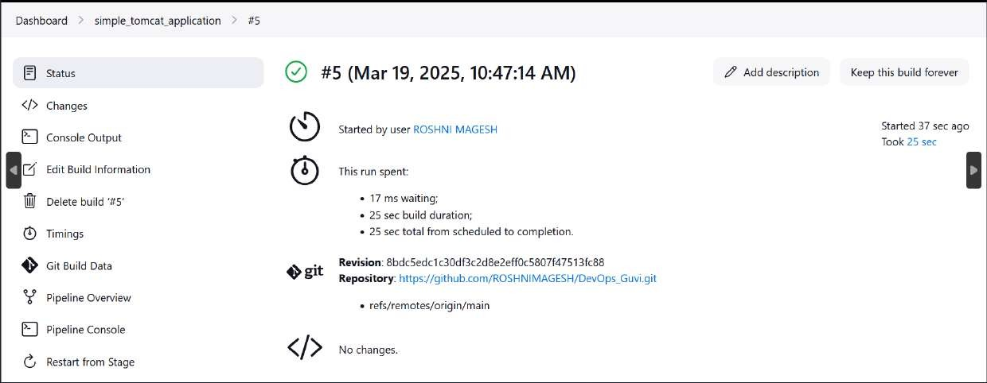

=>MINIKUBE

-->

curl -LO https://dl.k8s.io/release/v1.32.0/bin/linux/amd64/kubectl

sudo install -o root -g root -m 0755 kubectl /usr/local/bin/kubectl

--<

-->

chmod +x kubectl

mkdir -p ~/.local/bin

mv ./kubectl ~/.local/bin/kubectl

--<

kubectl version --client

-->

curl -LO https://github.com/kubernetes/minikube/releases/latest/download/minikube-linux-amd64

sudo install minikube-linux-amd64 /usr/local/bin/minikube && rm minikube-linux-amd64

--<

minikube start

docker ps (check is container is running)

kubectl get node

kubectl get pod (No resources found)

kubectl get pod -o wide (No resources found)

minikube status

kubeclt get deploy

kubectl get replica

